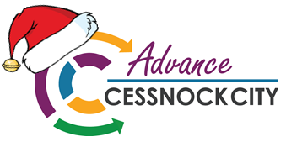 | CHRISTMAS SHUTDOWN CHECKLIST
Communication
Set up an out-of-office notifcation on your email account/s.
Update voice mail and answering service to include any holiday shutdown information.
Update website to include any shutdown information, including emergency contacts.
Post shutdown information to social media accounts. Advise if channels will be monitored over the break.
Housekeeping – office and workstations
Clean offices and workstations, including rubbish removal.
Remove perishables from the fridge and pantry. Consider defrosting.
Switch off and unplug all non-essential electrical items – the kettle, toaster, radio etc. Don’t forget lights and air-conditioning and other items that might be on a timer.
Reduce fire hazards by clearing out paper and cardboard waste.
Draw curtains and blinds to keep out the sun and keep the office cool.
IT
If you have one, contact your systems administrator to double check your IT needs wil be covered over the break.
Are you backed up? Check that your data is backed up and secure.
Sign out of online services and log off from Windows.
Shut down your machine completely.
Unplug!
Safety and security
If you have a security patrol, let them know when you will be closed.
Do an alarm audit. Who has an access code. Does anyone share a code?
Do a key audit. Who has which key and what do they open?
Lock all doors and windows – don’t forget the bathroom!
Secure all important, valuable or confidential items; make sure safes, filing cabinets and desk drawers are locked and the keys are secured.
Ask staff to consider taking home all valuable personal items.
Does your business have any hazardous materials onsite? Make sure they are secured and accounted for.
Staff
Ensure all staff are aware of holiday trading hours, including if they’re expected to work.

The Economic Development Unit of Cessnock City Council wishes you all a merry, safe and prosperous Christmas and New Year.

